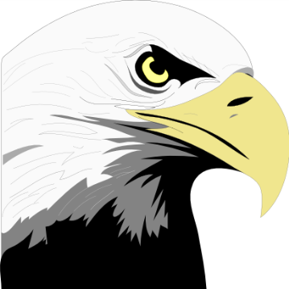 | Classroom | Cafeteria | Bus | Hallway | Common Area/ Office | Bathroom
Ready to Learn | - Be prepared  - Be on time  - ID on and visible  - Follow directions  1st time given | - ID on and visible  - Single file line while waiting for food | - Obey rules of the bus | - Walk quietly  - Go directly to class  - ID on and visible | - Keep space clean  - Model appropriate behavior for others | - Use restroom between classes
Respectful | - Use school appropriate language  - Sit appropriately  - No gum/candy  - Keep hands, feet and objects to self  - Treat equipment and materials carefully | - Keep food on tray  - Remain seated  - Obey lunch supervisors  - Keep hands/feet to self  - Use school appropriate language  - Speak in polite, quiet voices | - Remain seated  - Listen to the driver  - Use school appropriate language  - Use inside voices | - Walk Quietly  - Obey all Adults  - Keep hands and feet to self  - No technology | - Obey all school rules  - Stay in supervised area  - Model school appropriate behavior for others  - No technology | - Respect privacy  - Wash hands  - Keep restroom clean  - Put trash in the wastebasket
Responsible | - Be on task  - Clean after self  - Complete assignments | - Make nutritious choices  - Be a role model for others | - Collect belongings before getting on/off | - Model appropriate behavior  - No technology | - Model school appropriate behavior  - Use quiet voice  - Return to class as soon as possible | - Choose appropriate time to use restroom  - Walk quietly in hallway  - Return to class as soon as possible

